**For kali platform**

**Stpe 1 : (generating the payload )**

* Give the machine permission to root .

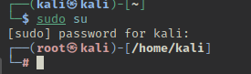

* Then set the payload for reverse tcp :

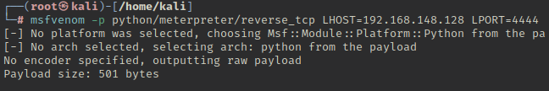

* Then activate the Apache server :

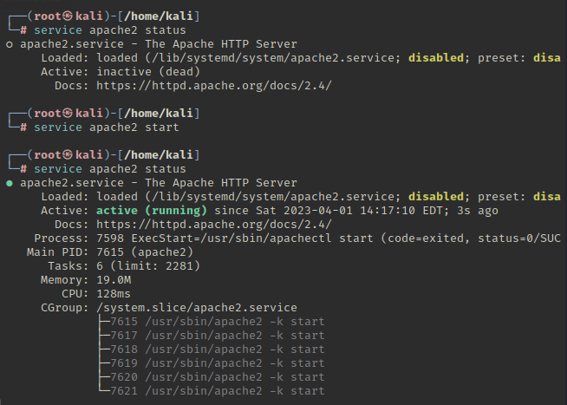

**Step 2 : (Configure the attacker site )**

* Open msfconsele



* Set the payload for msfconsole :



* Check the options and set the require information . Here I need to set my LHOST and LPORT is already set .

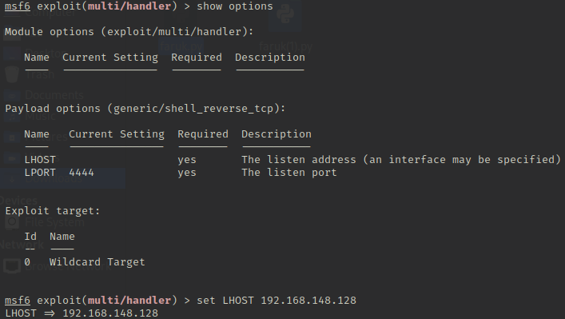

After all these type exploit and press enter . exploitation will start and wait for the target machine response . When the target machine download or open the payload file exploitation will start and attacker machine will get the full control of the target machine .

As demonstration I have download the faruk.py file using linux browser and open the file . it will activate the exploitation .

